Paper Prototype 1#

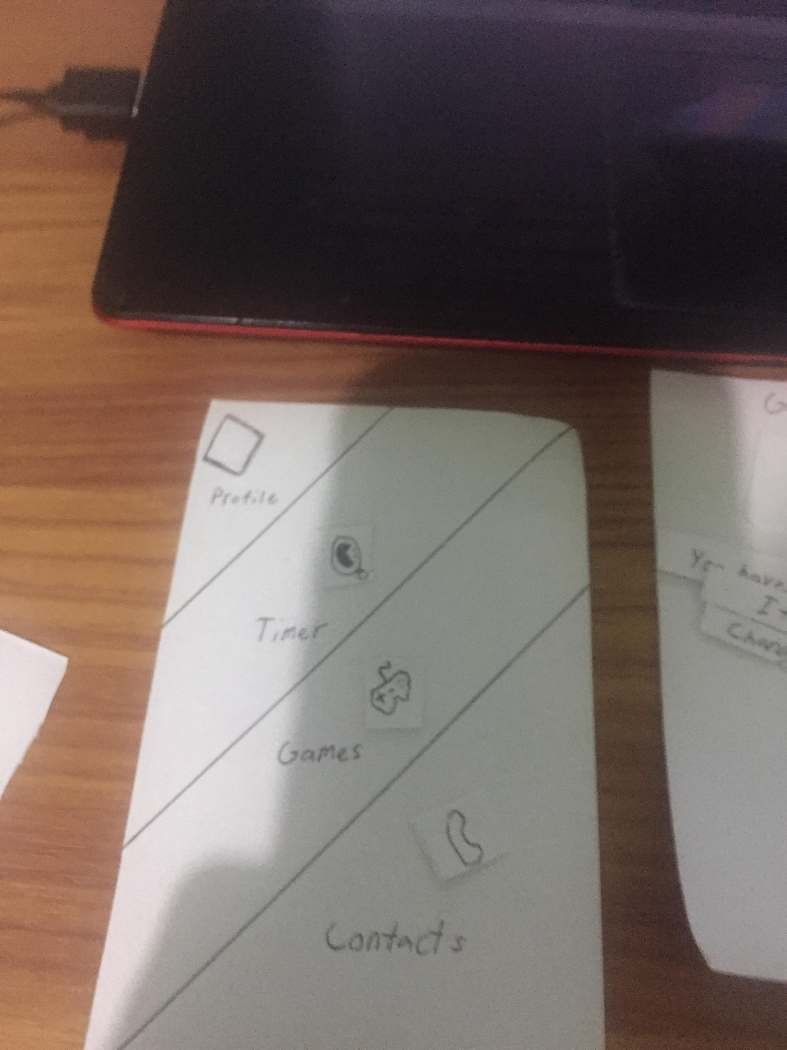

Menu of the GameStopper.

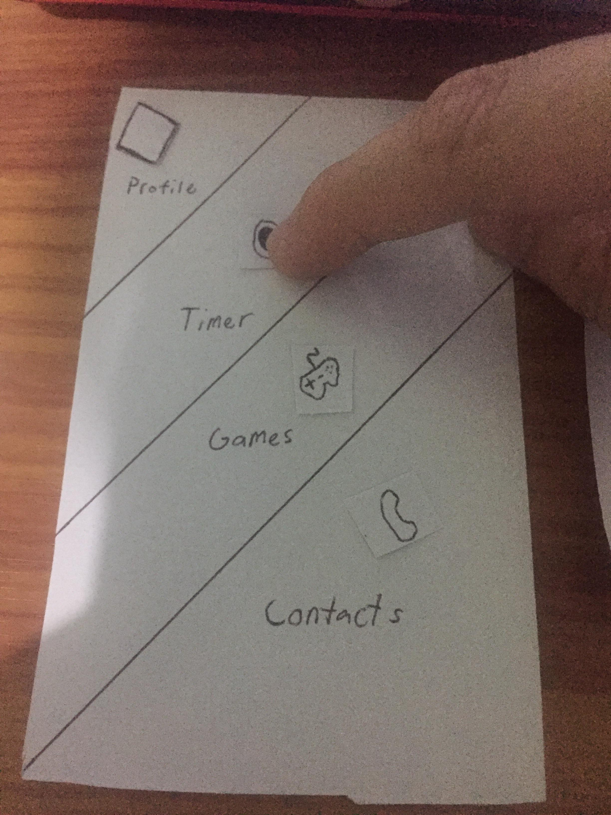

Pressing the timer.

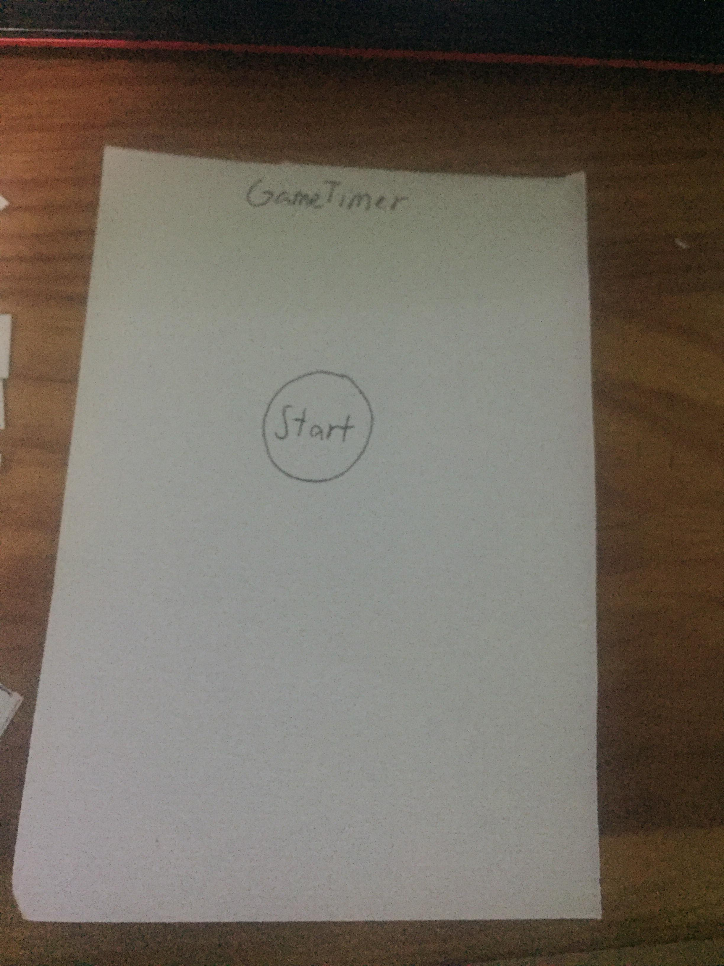

There will be a start button. Press it when you start playing.

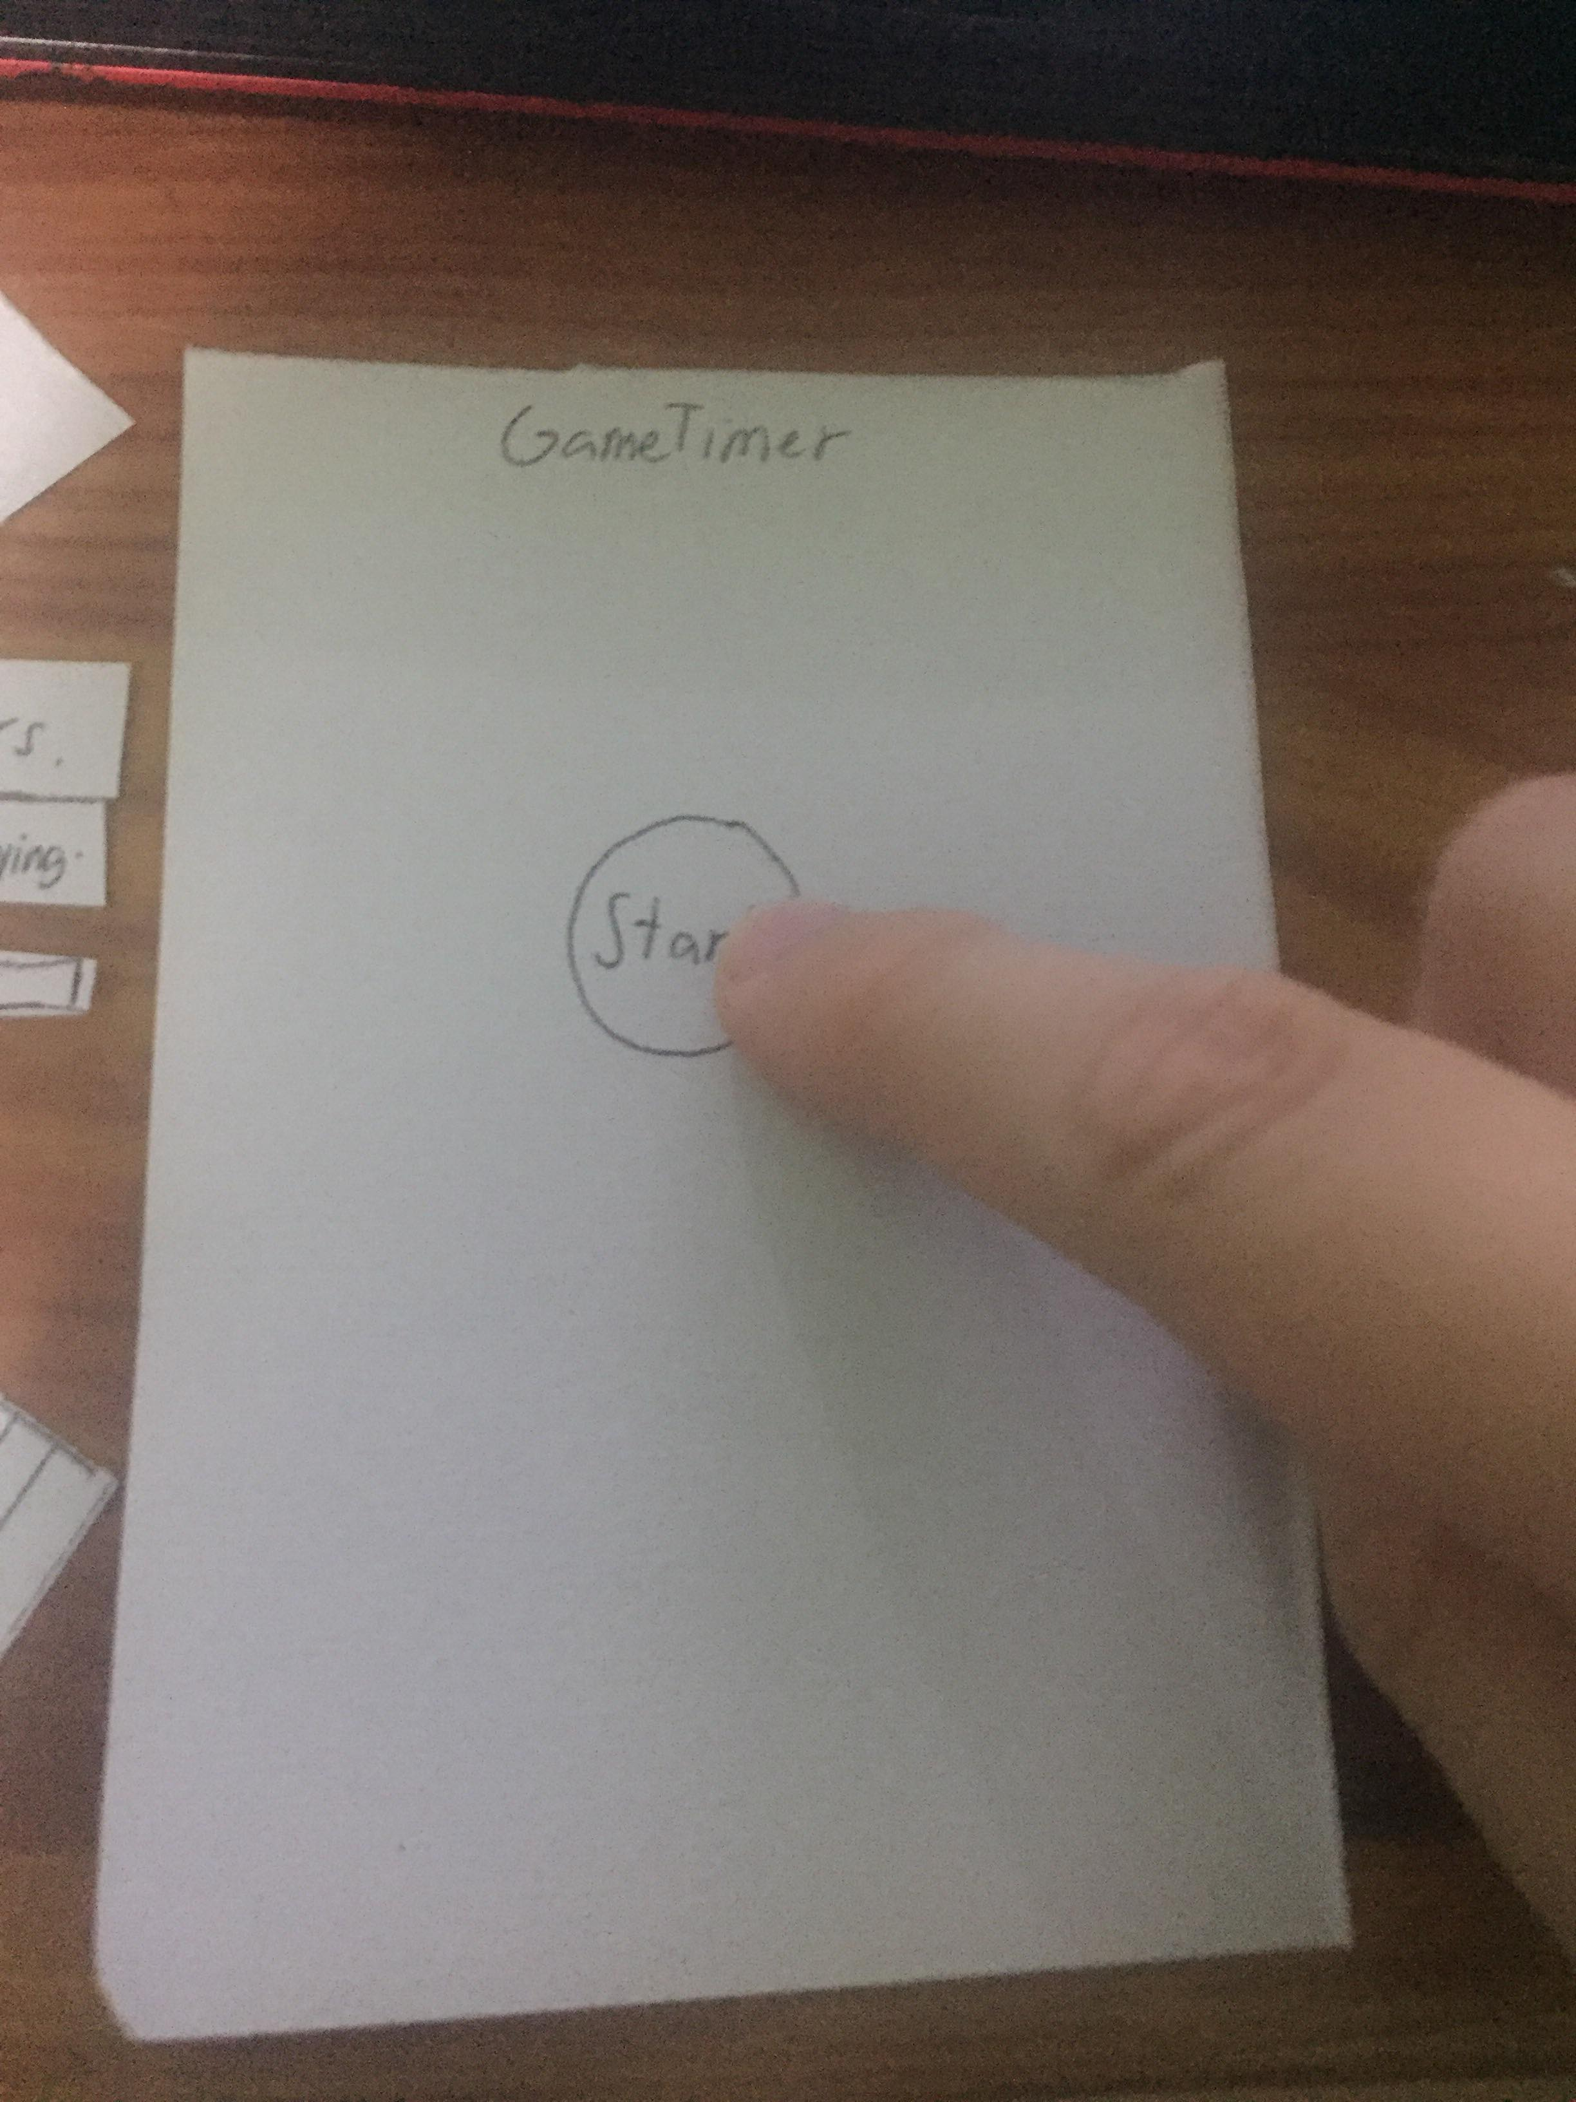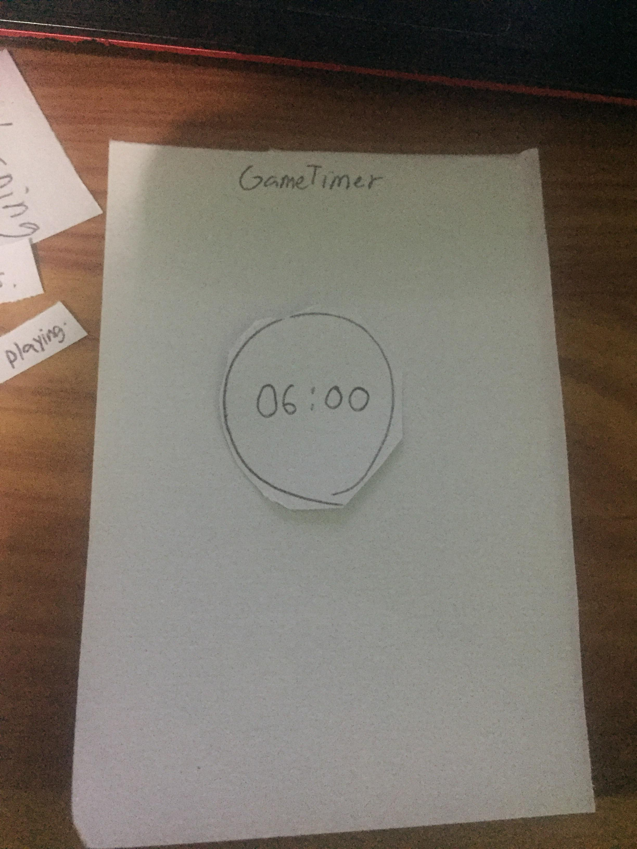

A timer will start.

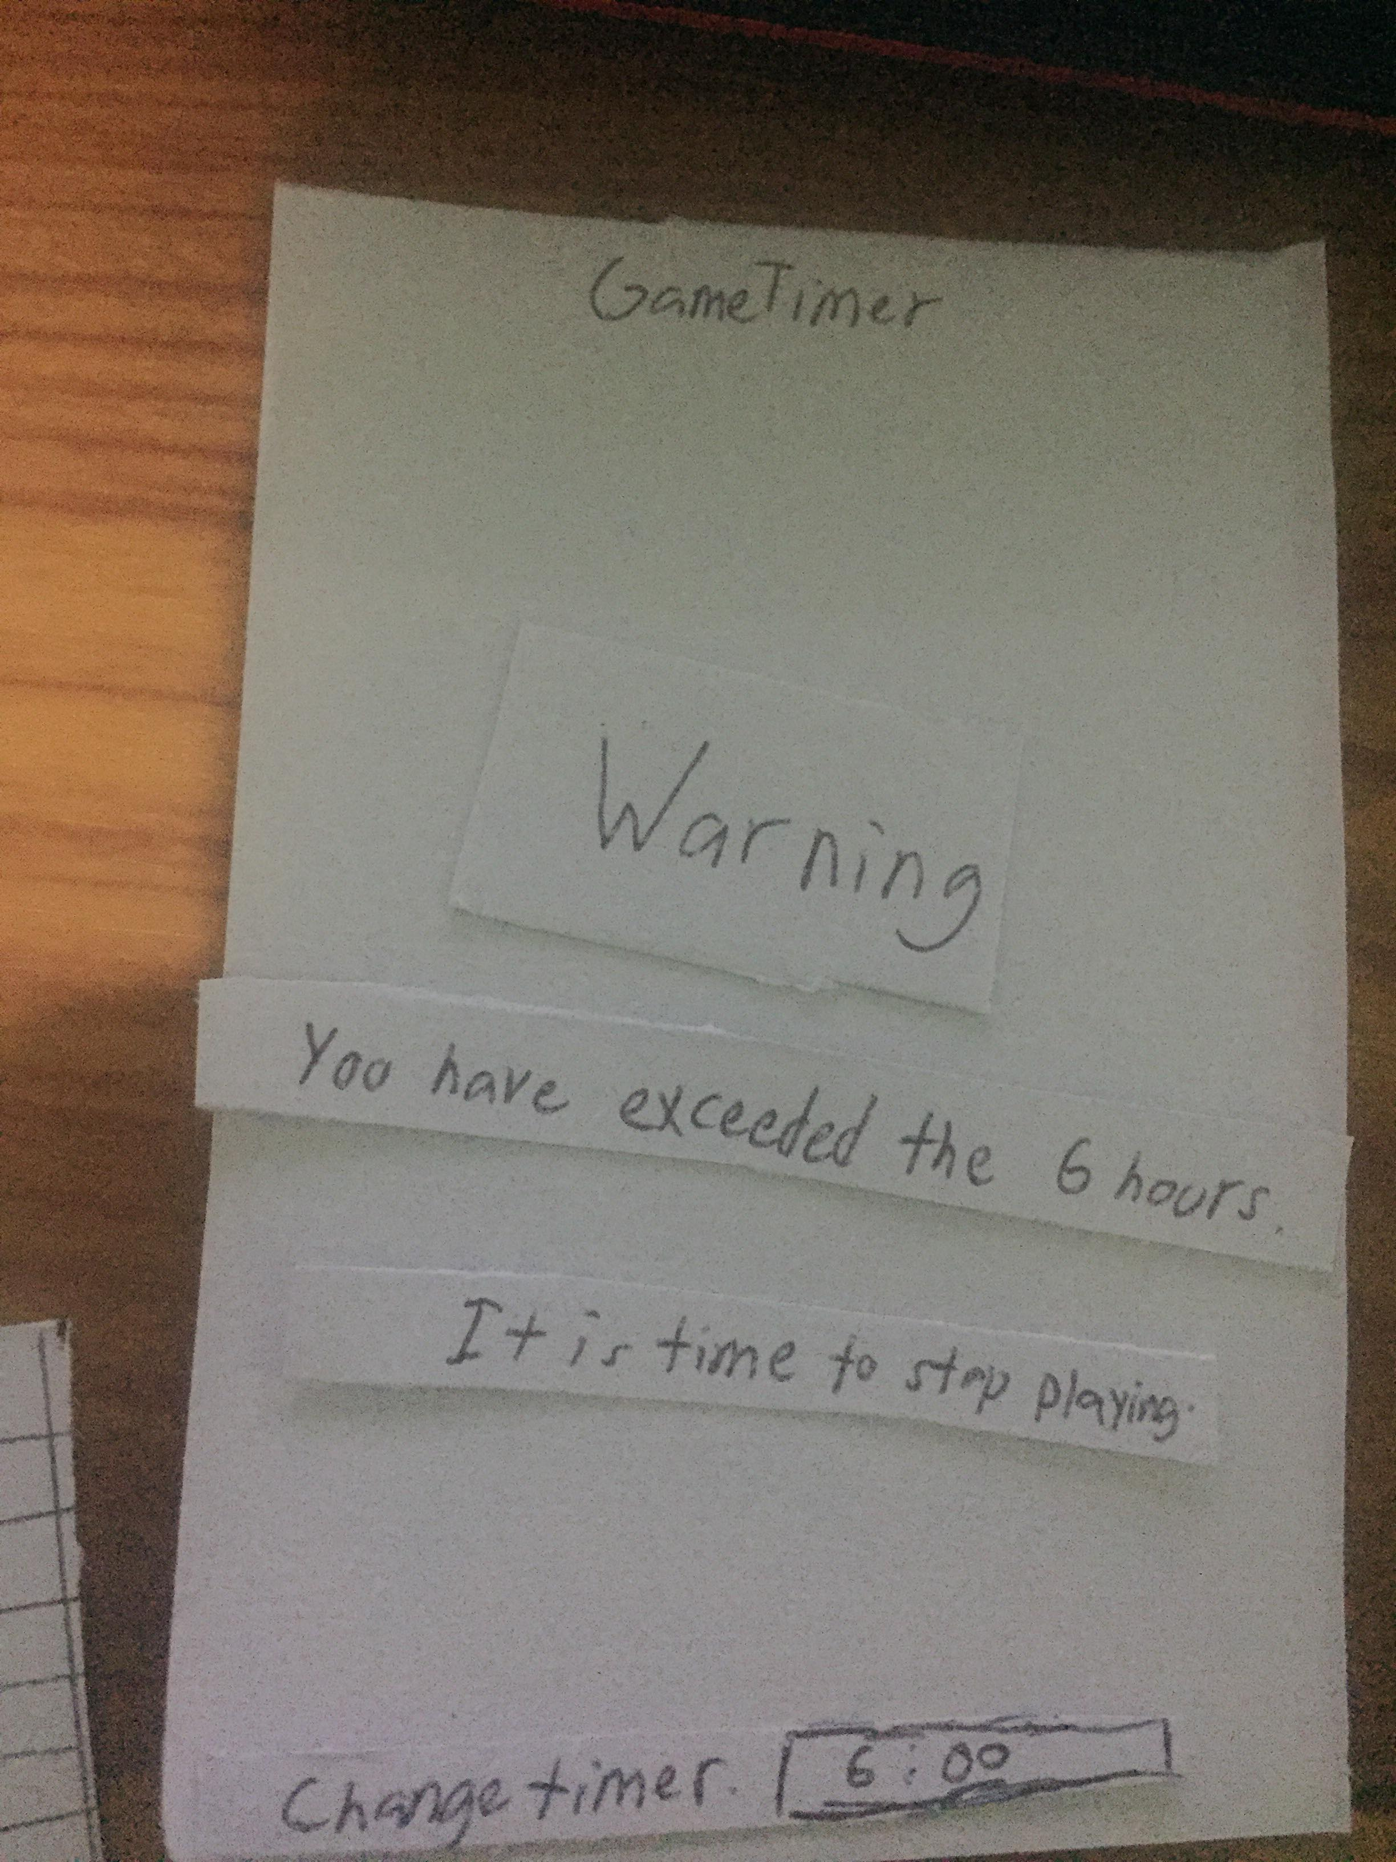

There will be an alarm and a warning to stop playing video games for now.

You can also change your timer.

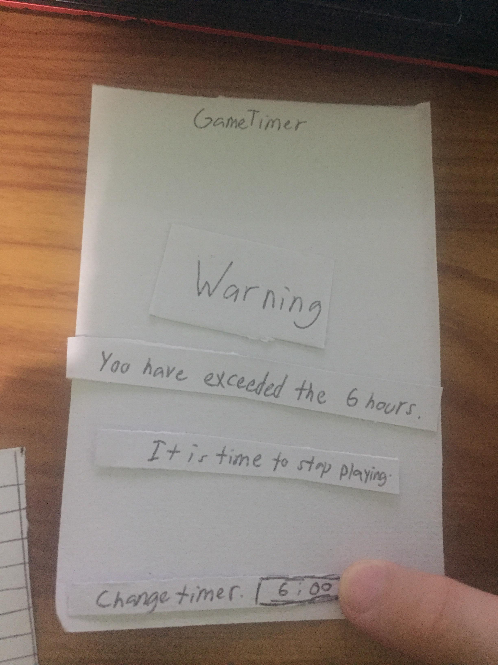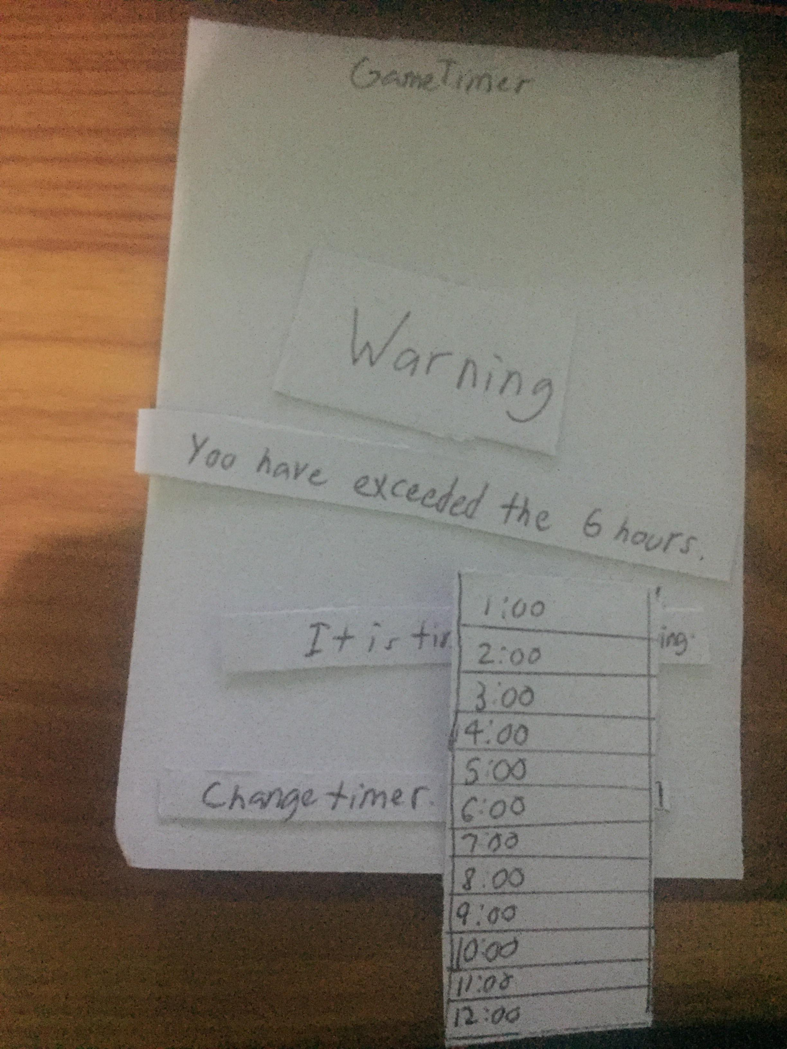

You can change the time.

Paper Prototype #2

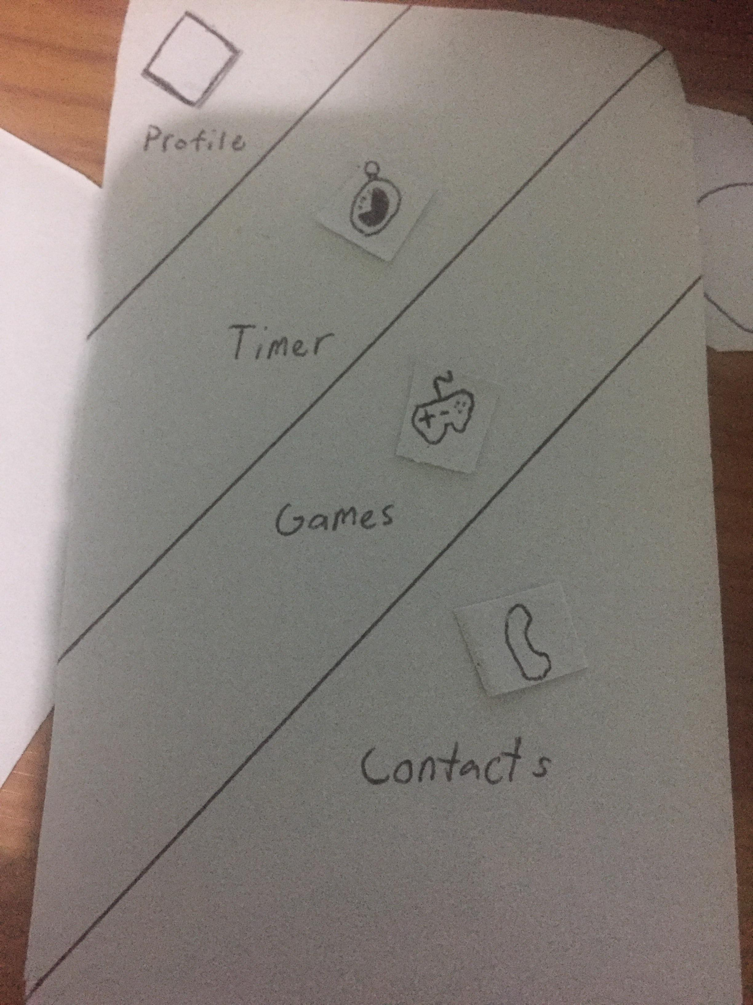

Menu of the GamerStopper.

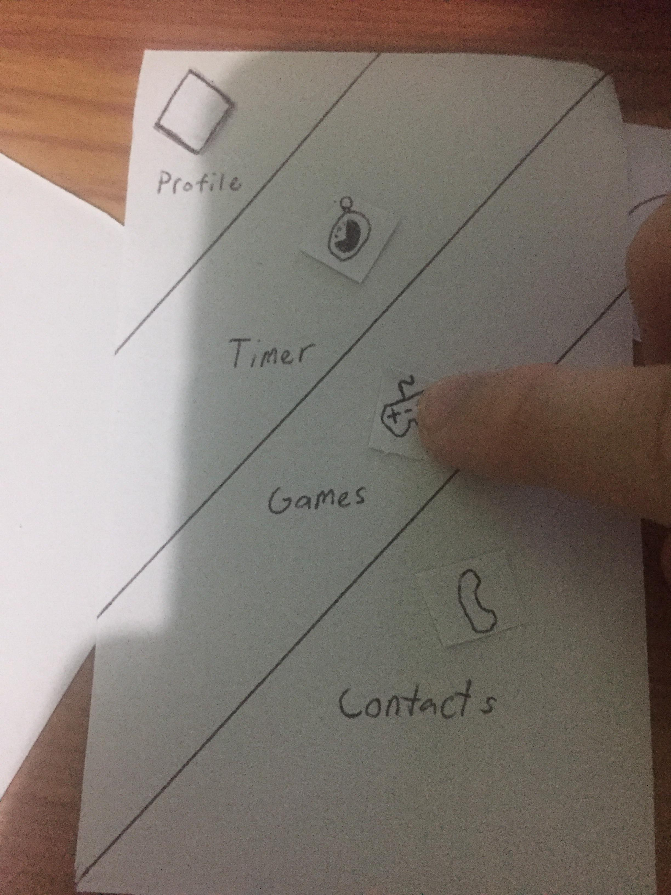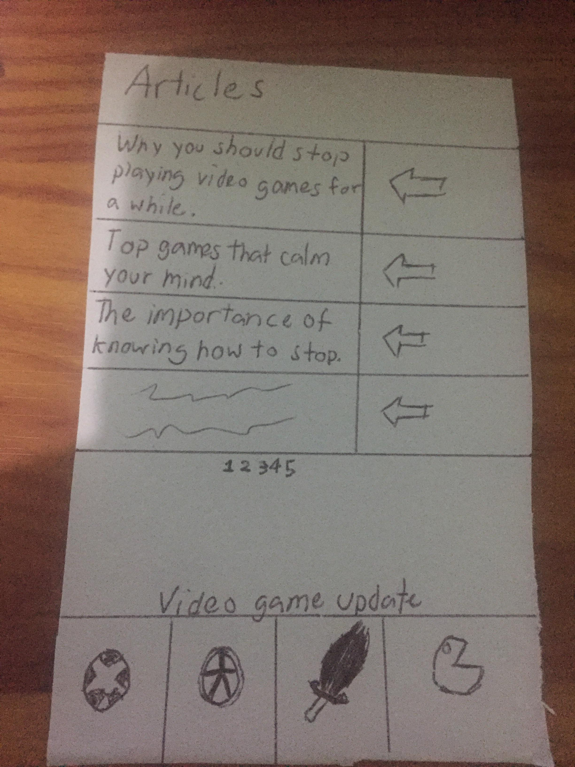

There will be articles to help you understand why video game addiction is important and video game updates if you are interested.

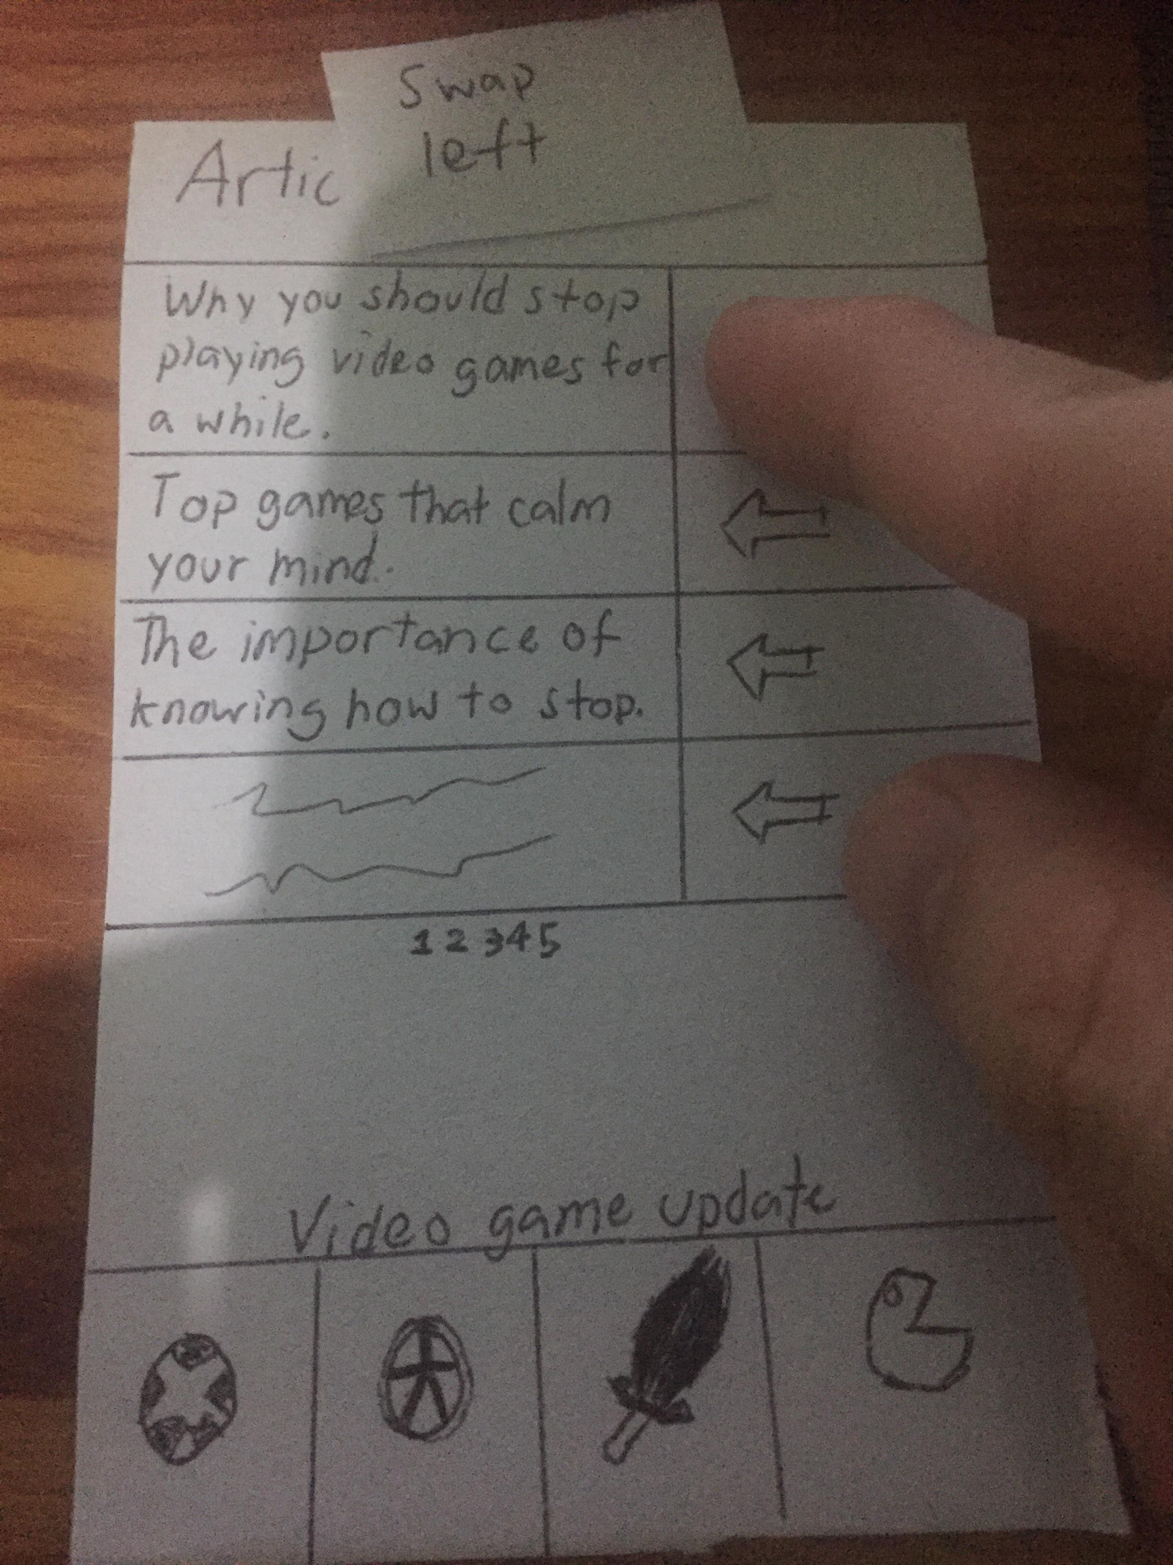

Swap left to go into an article.

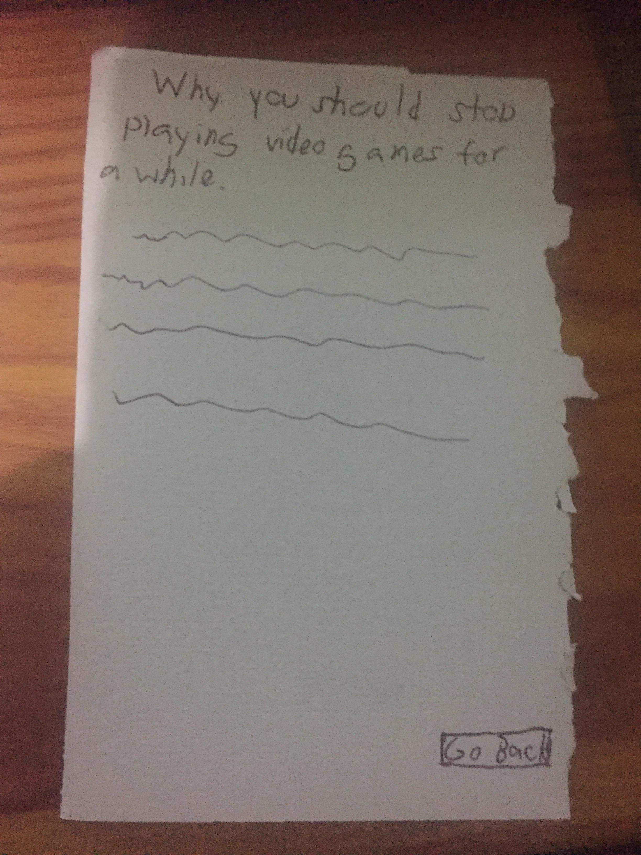

You can now fully read the article. You can go back as well.

POV.

Having trouble stopping playing video games? Why not manage your time.